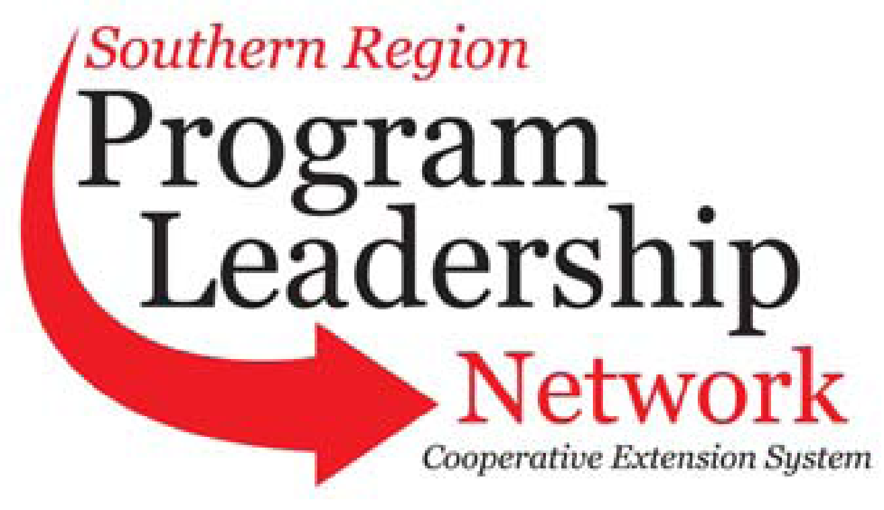

**September 1, 2025 – August 31, 2026**

***(See submission instructions at end of document)***

|  |  |  |  |
| --- | --- | --- | --- |
| Committee Name | CRD - PLN | Submission Contact Name: | Mark Rendleman |
| Chair | Mark Rendleman, OH | Submission Contact E-mail | mrendleman@centralstate.edu |
| Vice-Chair | Rachael Carter, MS | Submission Contact Phone | 513-218-8231 |
| Secretary | Courtney Howard, GA | Date of Submission | 8/20/2025 |
| PLC Representative 1862 | Sreedhar Upendram (2027) | PLC Representative 1890 | Terence Norwood, AL (2028) |
| 1862 Advisor | Tom Dobbins | 1890 Advisor | Jennifer Wells Marshall |

**Annual Plan of Work**

**September 1, 2025 – August 31, 2026**

| Item to Accomplish | Responsibility  (Names of people assigned to item) | Key Contact  (Person who will serve as a key contact for item) | Goal Date  (Anticipated completion date) | Completion Date  (to be filled in when completed) |
| --- | --- | --- | --- | --- |
| Share CRD programming and resources across the region by contributing to SRDC’s *Around the South* newsletter highlighting program and person.  http://srdc.msstate.edu/newsletters/ats/ | All Program Leaders, SRDC | Grace Langford | July, 2026 |  |
| Continue to collect CRD indicators | All Program Leaders, SRDC | Roseanne Scammahorn | July, 2026 |  |
| Host a Working Group to expand the capacity of committee members to collect and report indicators | Stacey McCullough, Adam Hodges, Iris Crosby, Melissa Bond, Roseanne Scammahorn, James Arati, Mark Rendleman, Novita Epps, Chrystol Thomas, Kimberly Davis | Stacey McCullough | July 2026 |  |
| Begin to update existing “Cashing in on Business” curriculum  https://srdc.msstate.edu/cashing/ | Terence Norwood, Roseanne Scammahorn, Krystle J. Allen, Jimmy Henry, Rachael Carter, Adam Hodges, Gill Finley, James Barnes, James Arati, Al McIntosh, Chrystol Thomas, Sreedhar Upendram | Terence Norwood | July 2026 |  |
| Continue CED 101 curriculum development/ Training/ Online Webinars | Hunter Goodman, Jamie Rae-Walker, Sreedhar Upendram, Crystal Tyler-Mackey, Dan Kahl, Natriez Peterson, Mark Rendleman, Michelle Eley, Rachael Carter, Stacey McCullough, Yolanda Surrency, Al McIntosh, Teron Speer, Jimmy Henry | Hunter Goodman/  Sreedhar Upendram | July, 2026 |  |
| Showcase CRD program evaluation techniques/ Conduct Training | Krystle Allen, Gill Finley Jr., Mark Rendleman, Melissa Bond, Alfred McIntosh, Jennifer Wells-Marshall, James Arati, Nate Peterson, Novita Epps, Crystal Tyler-Mackey, Lindsey Lunsford | Krystle Allen/ Iris Crosby/ Jennifer Wells-Marshall | July, 2026 |  |
| Host a virtual training series focused on grant writing, funding acquisition, and strategic partnership development to strengthen Extension capacity and increase external resource opportunities for community programs. | Stacey McCullough, Courtney Howard, Hunter Goodman, Kateira Hogan, Kenny Sherin, Iris Crosby | Stacey McCullough, Iris Crosby | July, 2026 |  |

Quarterly Conference Call Schedule: (Dates/Times – Please indicate time zone)

Nov. 12, 2025

Feb. 11, 2026

April 8, 2026

July 8, 2026

All calls at 2:00pm ET/1:00pm CT

To add more lines, if needed: Place cursor in last box of the last row. Hit “tab.” Another row should appear.

***Submission instructions:***

Rename the document with your committee name initials (ANR, CRD, COM, FCS, 4H, ITS, MM, PSD, PLC) such as: ANRplanofwork.doc

Email document to HYPERLINK "mailto:r.scammahorn@msstate.edu"r.scammahorn@msstate.edu

If you have problems, contact Roseanne Scammahorn at HYPERLINK "mailto:r.scammahorn@msstate.edu"r.scammahorn@msstate.edu